**Circuit and System-I Lab**

**LAB # 09 & 10**



**Spring 2022**

Submitted by: Ali Asghar

Registration No.: **21PWCSE2059**

Class Section: **C**

“On my honor, as student of University of Engineering and Technology, I have neither given nor received unauthorized assistance on this academic work.”

Student Signature: ______________

Submitted to:

**Engr. Faiz Ullah**

15 June, 2022

Department of Computer Systems Engineering

**ASSESSMENT RUBRICS LAB # 9 & 10**

**Thevenin’s and Norton’s theorem using PSpice**

|  |  |  |
| --- | --- | --- |
| **Criteria** | **Excellent** | **Marks Obtained** |
| 1. **Objectives of Lab** | All objectives of lab are properly covered  [Marks 0.5] |  |
| 1. **Thevenin and Norton’s Theorem** | Brief introduction to both the theorems and circuit diagrams and mention “ab” terminal points.  [Marks 1.5] |  |
| 1. **PSpice** | Brief introduction and steps for simulation  [Marks 2] |  |
| 1. **Observations and calculations** | Each step to obtain final result along with circuit diagrams  [Marks 5] |  |
| 1. **Conclusion** | Conclusion obtained from readings  [Marks 1] |  |

**Title:**

**Thevenin’s and Norton’s theorem using PSpice**

**Objectives:**

* To Verify and understand Thevenin’s and Norton’s Theorem
* To be able to build Thevenin’s and Norton’s circuits in PSPICE

**THEVENIN’s THEOREM :**

Thevenin’s Theorem states that any combination of batteries and resistances with two terminals can be replaced by a single voltage source and a single series resistor. The value of voltage source is the open circuit voltage at the terminals, and the value of single series resistor is voltage divided by the current with the terminals short circuited.

# mATHEMATICALLY :

# Norton’s Theorem :

Any collection of batteries and resistances with two terminals is electrically equivalent to an ideal current source i in parallel with a single resistor r. The value of r is the same as that in the Thevenin equivalent and the current i can be found by dividing the open circuit voltage(VOP) by resistance(RTH).

# mATHEMATICALLY :

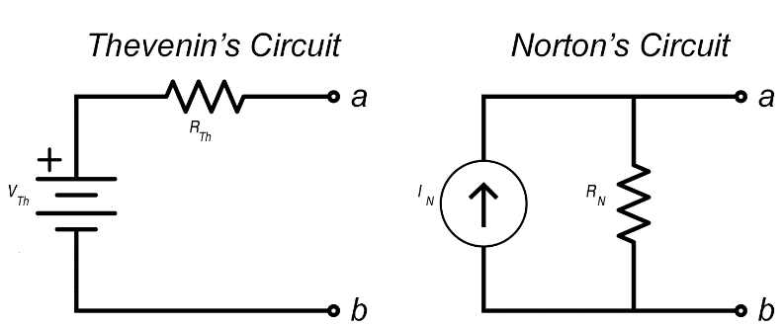

**PSPICE:**

**PSpice** is a SPICE analog circuit and digital logic simulation software that runs on personal computers, hence the first letter "P" in its name. It was developed by MicroSim and is used in electronic design automation. MicroSim was bought by OrCAD which was subsequently purchased by Cadence Design Systems. The name is an acronym for Personal Simulation Program with Integrated Circuit Emphasis. Today it has evolved into an analog mixed signal simulator.

OR

“PSPICE is a circuit analysis tool that allows the user to simulate a circuit and extract key voltages and currents.”

# Proving the Thevenin’s Theorem using the pspice:

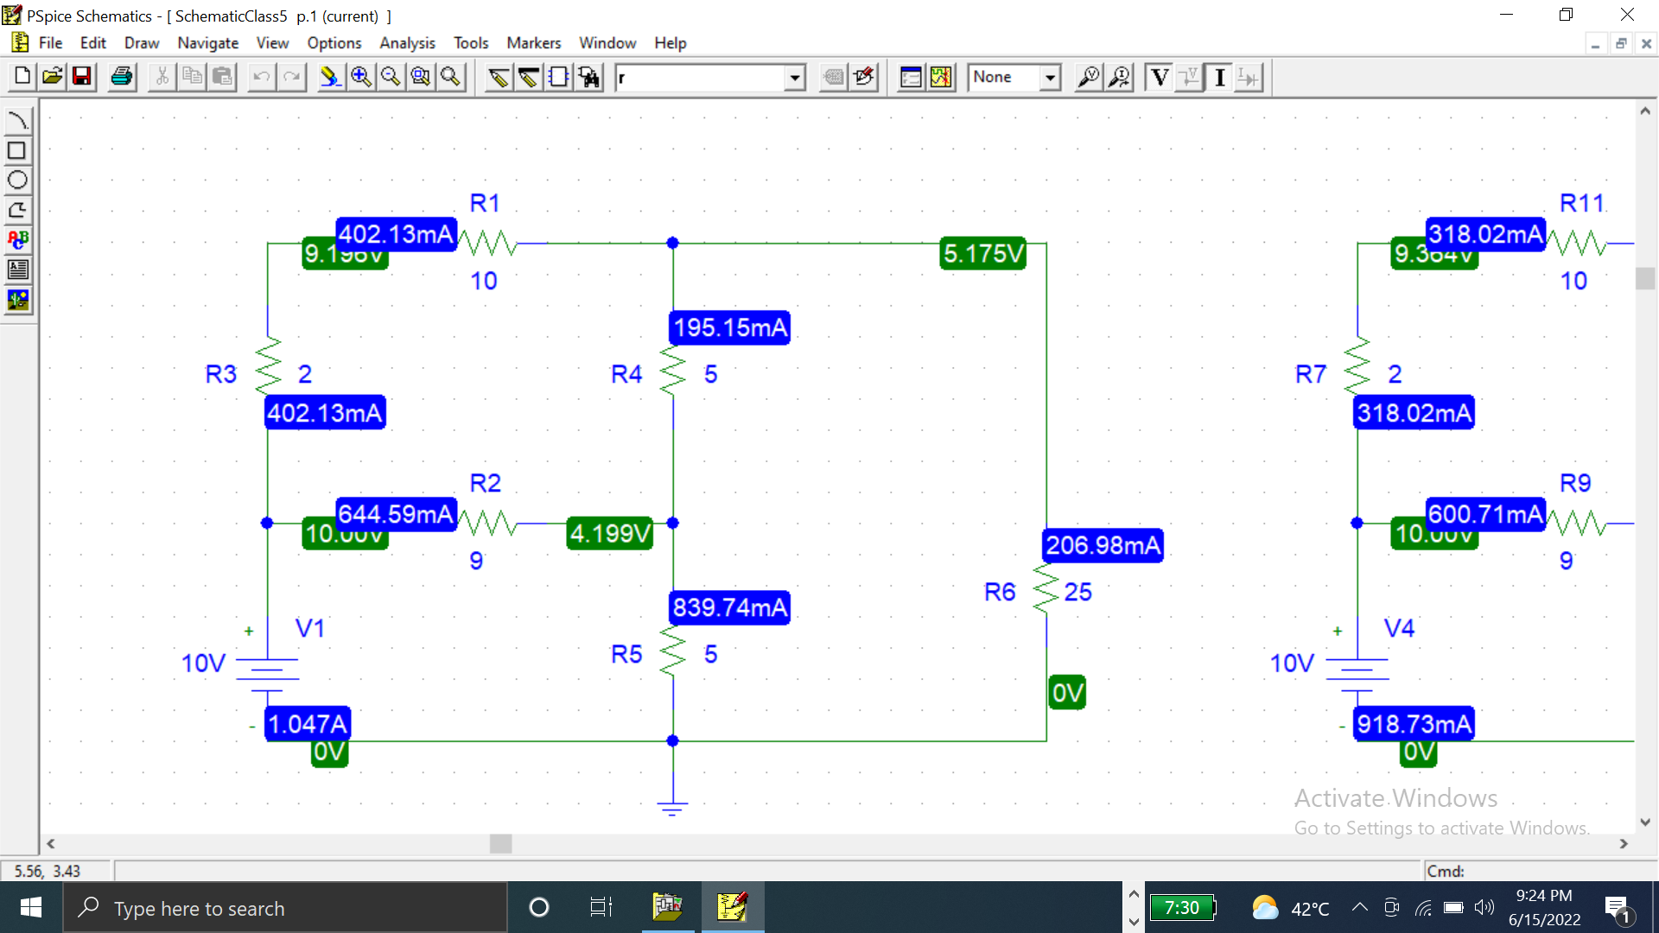

Figure 1

Figure 1 shows the initial circuit I built using PSPICE. This circuit will be used to verify thevenin’s theorem. Here we will apply thevenin’s theorem on R6. Here we note the values IL and VL which we will verify in the end. **IL = 206.98 mA** and **VL = 5.175 V** in this case.

**STEP 1(Finding v(Open circuit)):**

VOP can be found by removing R6 from the circuit and leaving it open. Now voltage drop across the open terminals is Vth(V Thevenin). **Vth = VOP = 6.184 V** as shown in figure 2.

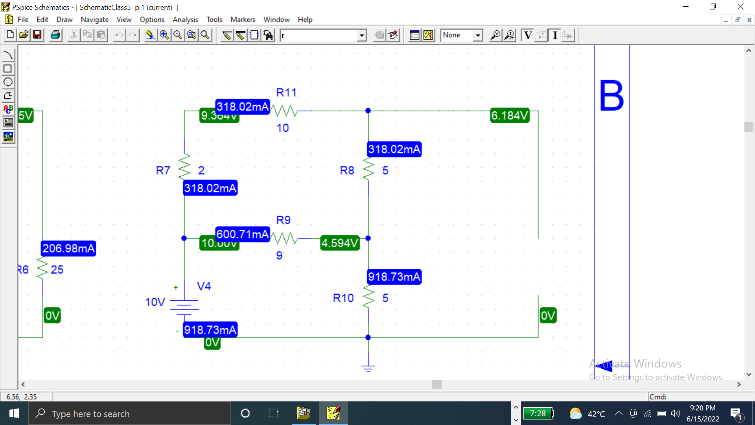

Figure 2

**STEP 2(Finding I(SHORT circuit)):**

Now in step 2, We find ISC by short circuiting the open terminals across R6.

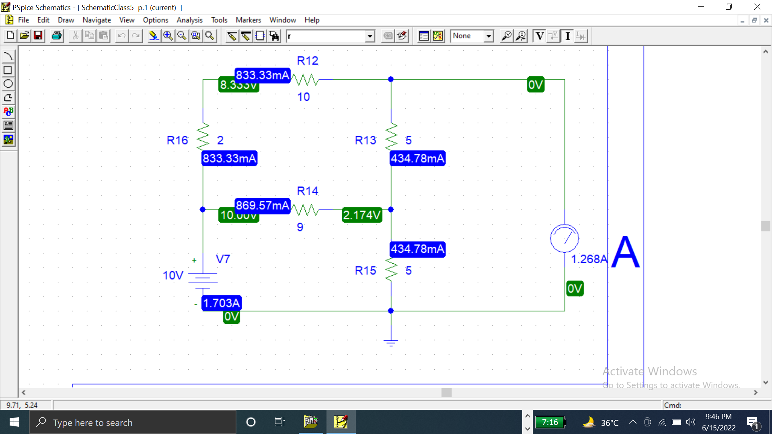

Figure 3

In Figure 3, I have placed an ammeter to find ISC. **ISC = 1.268A** as shown in figure 3.

**STEP 3:**

In step 3, First we calculate RTH by dividing the formula:

*Putting given values in above equation*

So Now we replace the whole circuit with a resistor having **RTH()** Value and connected with voltage source of value **VTH()** and **R6(25)** in series.

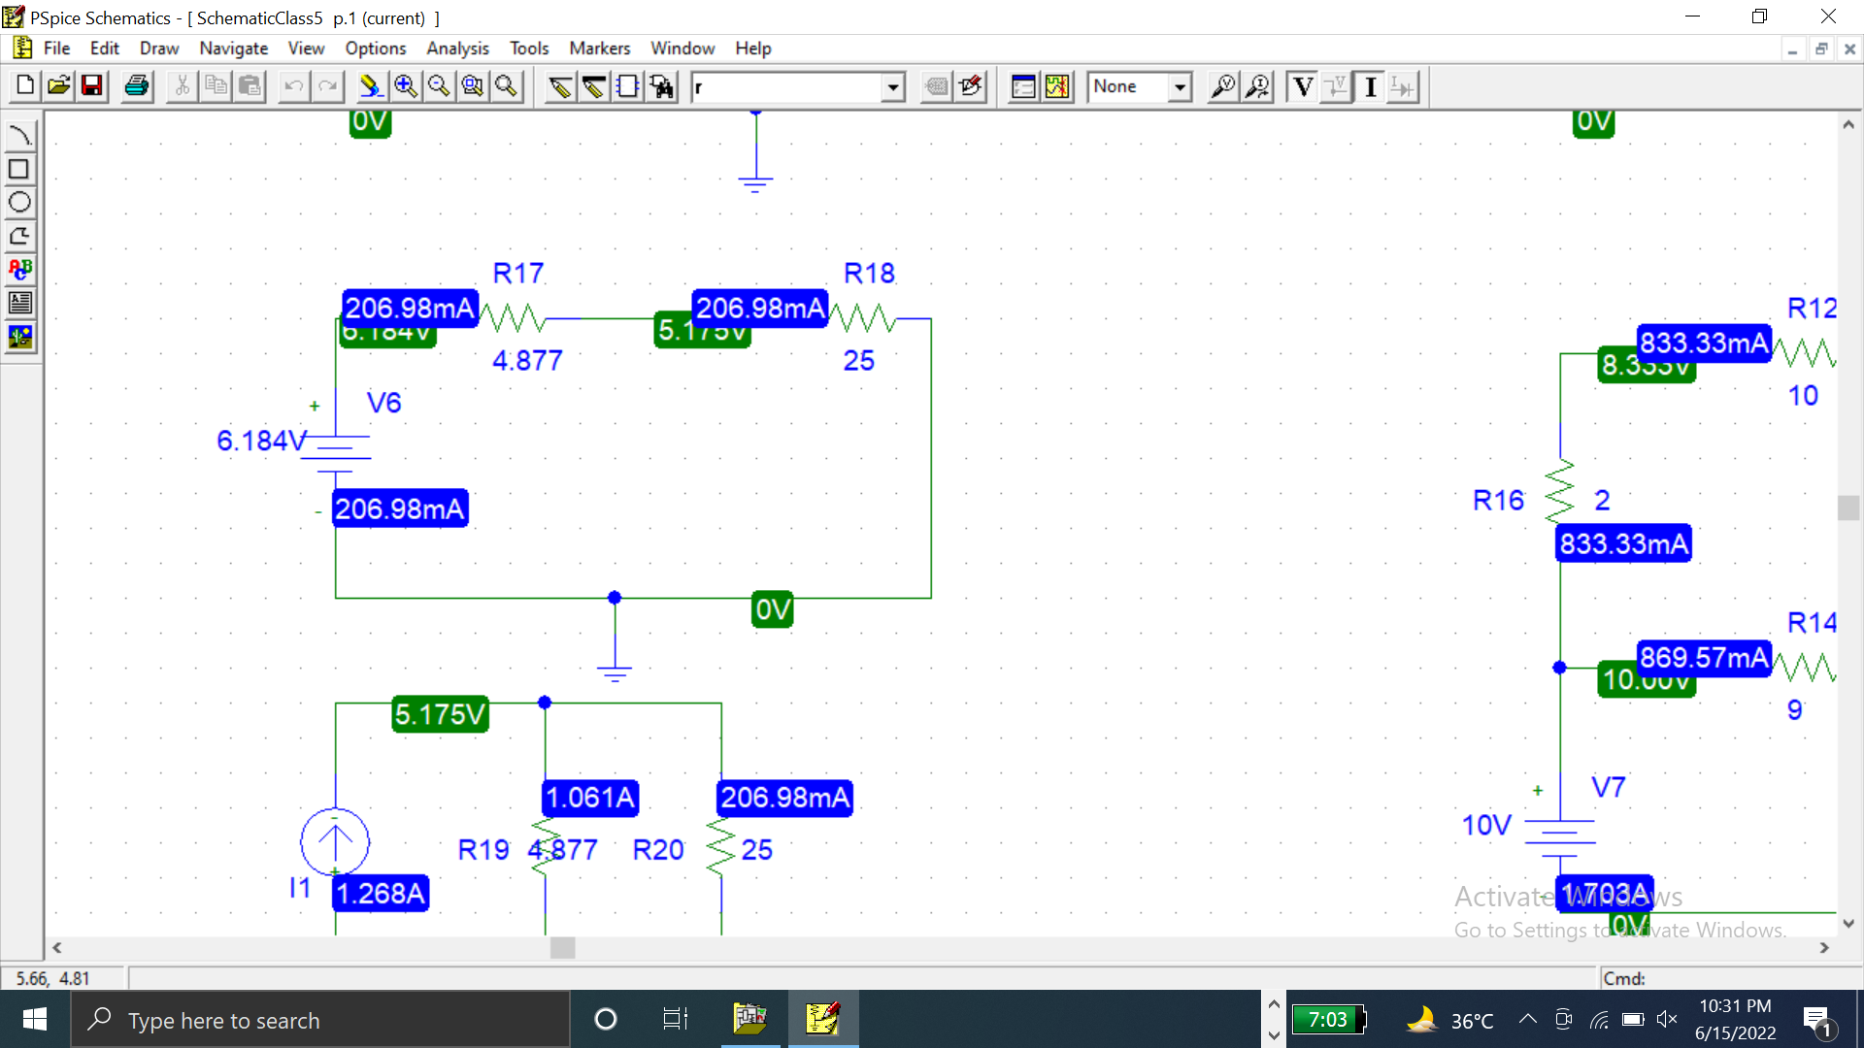

Figure 4

# Proving the NORTON’S Theorem using the pspice:

Norton’s equivalent circuit can be obtained by using source transformation.

The value of current source is given by:

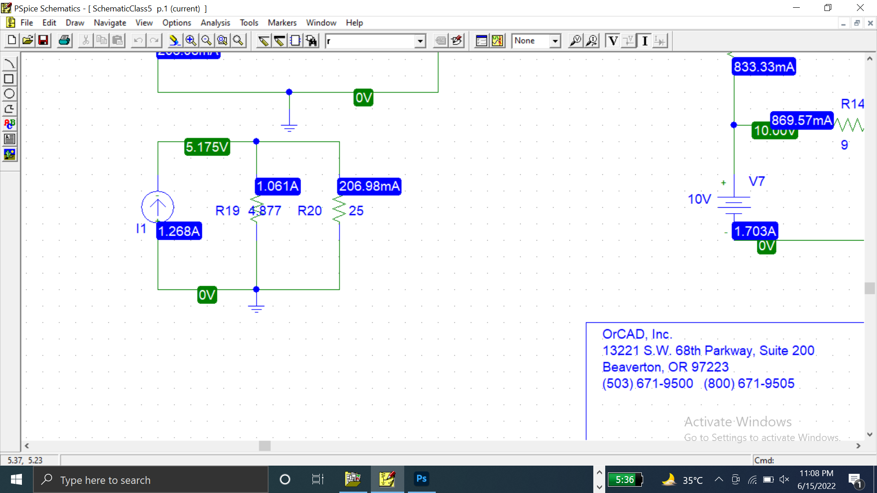

Figure 5

Figure 5 shows the Norton’s equivalent circuit of Thevenin’s circuit shown in figure 4.

**CONCLUSION:**

Finally, we verified the Thevenin’s and Norton’s theorem by comparing the voltage drop values across R6. We simplified the whole network of resistors into a simple circuit by applying Thevenin’s and Norton’s theorem.